Gaming-Bets

Version 1.0

Revision History

|  |  |  |  |
| --- | --- | --- | --- |
| **Date** | **Version** | **Description** | **Author** |
| 03.11.2015 | 1.0 | Basic Information | André Helbig |
|  |  |  |  |
|  |  |  |  |
|  |  |  |  |

Table of Contents

1. Use-Case Name 4

1.1 Brief Description 4

2. Flow of Events 4

2.1 Basic Flow 4

2.2 Alternative Flows 5

2.2.1 Cannot reach server 5

3 Special Requirements 5

4 Preconditions 5

4.1 App started 5

4.2 Internet Connection 5

4.3 User must be logged in as an admin 5

5 Postconditions 5

5.1 Notification and redirection 5

6 Extension Points 5

# Use-Case Name

## Brief Description

This Use-Case will allow an admin to manage the user data of all users. At first he will have a list of all users and after selecting one he will be in the Edit user data Use Case for that user.

# Flow of Events

# Basic Flow

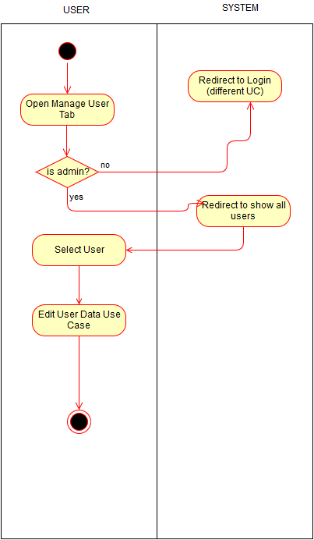

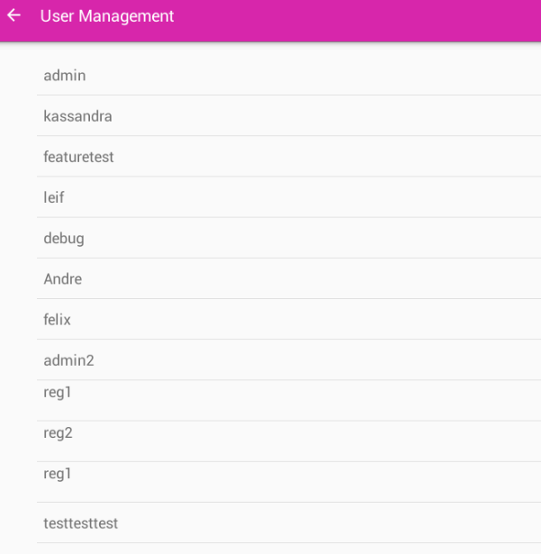

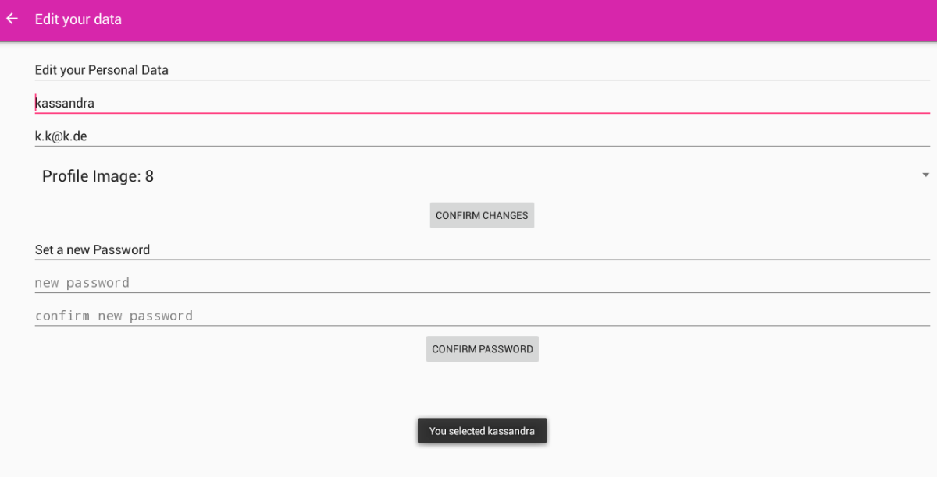

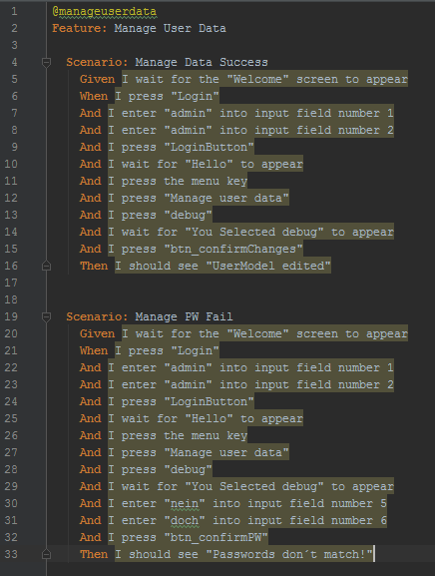

## Alternative Flows

### Cannot reach server

If the changes cannot be transmitted to the server, the user will be notified if possible via app. He will be asked to try it again later.

# Special Requirements

n/a

# Preconditions

## App started

The app must be running.

## Internet Connection

To submit feedback or a message, an internet connection is necessary.

## User must be logged in as an admin

To manage other users data, you have to be logged in as an admin.

# Postconditions

## Notification and redirection

As soon as the changes were done by the system, the user will be notified about the success and will be redirected to the personal profile.

# Extension Points

n/a

# Function Points

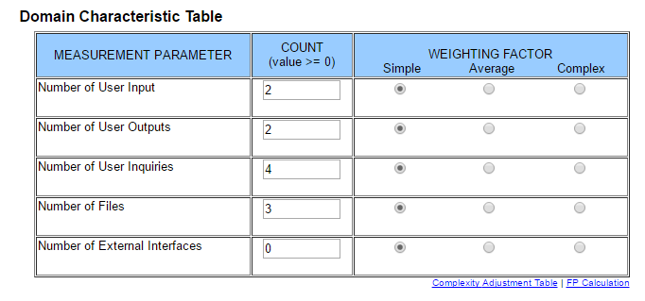

This results in a function point calculation of **30.5**.